# Driver Total:121

# 1 switch:

/Users/wpf/Desktop/log/test/linux-2.6.9/arch/cris/arch-v10/drivers/gpio.c

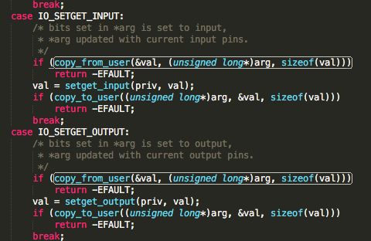

/Users/wpf/Desktop/log/test/linux-2.6.9/drivers/atm/zatm.c

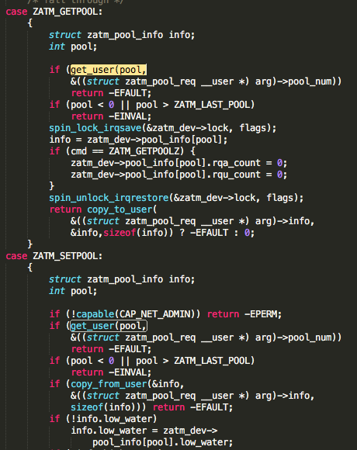

/Users/wpf/Desktop/log/test/linux-2.6.9/drivers/block/DAC960.c

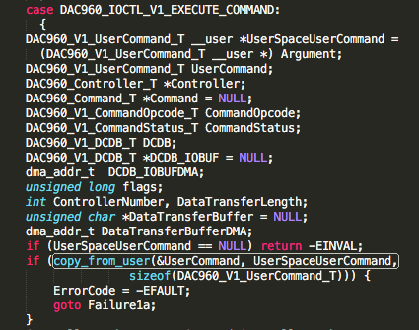

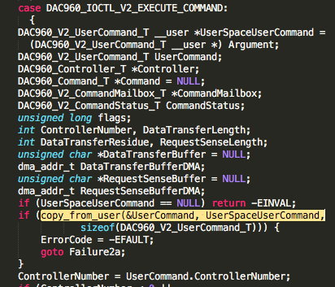

/Users/wpf/Desktop/log/test/linux-2.6.9/drivers/block/ataflop.c

/Users/wpf/Desktop/log/test/linux-2.6.9/drivers/block/cpqarray.c

/Users/wpf/Desktop/log/test/linux-2.6.9/drivers/block/ioctl.c

/Users/wpf/Desktop/log/test/linux-2.6.9/drivers/block/scsi_ioctl.c

/Users/wpf/Desktop/log/test/linux-2.6.9/drivers/cdrom/aztcd.c

/Users/wpf/Desktop/log/test/linux-2.6.9/drivers/cdrom/sjcd.c

/Users/wpf/Desktop/log/test/linux-2.6.9/drivers/cdrom/sonycd535.c

/Users/wpf/Desktop/log/test/linux-2.6.9/drivers/char/ds1286.c

/Users/wpf/Desktop/log/test/linux-2.6.9/drivers/char/epca.c

/Users/wpf/Desktop/log/test/linux-2.6.9/drivers/char/genrtc.c

/Users/wpf/Desktop/log/test/linux-2.6.9/drivers/char/ipmi/ipmi_devintf.c

/Users/wpf/Desktop/log/test/linux-2.6.9/drivers/char/ipmi/ipmi_watchdog.c

/Users/wpf/Desktop/log/test/linux-2.6.9/drivers/char/isicom.c

/Users/wpf/Desktop/log/test/linux-2.6.9/drivers/char/mwave/mwavedd.c

/Users/wpf/Desktop/log/test/linux-2.6.9/drivers/char/pcxx.c

/Users/wpf/Desktop/log/test/linux-2.6.9/drivers/char/ppdev.c

/Users/wpf/Desktop/log/test/linux-2.6.9/drivers/char/rtc.c

/Users/wpf/Desktop/log/test/linux-2.6.9/drivers/char/vt_ioctl.c

/Users/wpf/Desktop/log/test/linux-2.6.9/drivers/char/watchdog/alim7101_wdt.c

/Users/wpf/Desktop/log/test/linux-2.6.9/drivers/char/watchdog/sbc60xxwdt.c

/Users/wpf/Desktop/log/test/linux-2.6.9/drivers/char/watchdog/sc520_wdt.c

/Users/wpf/Desktop/log/test/linux-2.6.9/drivers/char/watchdog/w83877f_wdt.c

/Users/wpf/Desktop/log/test/linux-2.6.9/drivers/ieee1394/pcilynx.c

/Users/wpf/Desktop/log/test/linux-2.6.9/drivers/ieee1394/raw1394.c

/Users/wpf/Desktop/log/test/linux-2.6.9/drivers/ieee1394/video1394.c

/Users/wpf/Desktop/log/test/linux-2.6.9/drivers/input/evdev.c

/Users/wpf/Desktop/log/test/linux-2.6.9/drivers/input/joydev.c

/Users/wpf/Desktop/log/test/linux-2.6.9/drivers/isdn/act2000/module.c

/Users/wpf/Desktop/log/test/linux-2.6.9/drivers/isdn/capi/capi.c

/Users/wpf/Desktop/log/test/linux-2.6.9/drivers/isdn/capi/kcapi.c

/Users/wpf/Desktop/log/test/linux-2.6.9/drivers/isdn/i4l/isdn_common.c

/Users/wpf/Desktop/log/test/linux-2.6.9/drivers/isdn/pcbit/drv.c

/Users/wpf/Desktop/log/test/linux-2.6.9/drivers/isdn/sc/ioctl.c

/Users/wpf/Desktop/log/test/linux-2.6.9/drivers/media/video/planb.c

/Users/wpf/Desktop/log/test/linux-2.6.9/drivers/media/video/saa7134/saa7134-oss.c

/Users/wpf/Desktop/log/test/linux-2.6.9/drivers/media/video/stradis.c

/Users/wpf/Desktop/log/test/linux-2.6.9/drivers/media/video/zr36120.c

/Users/wpf/Desktop/log/test/linux-2.6.9/drivers/mtd/mtdchar.c

/Users/wpf/Desktop/log/test/linux-2.6.9/drivers/net/3c509.c

/Users/wpf/Desktop/log/test/linux-2.6.9/drivers/net/amd8111e.c

/Users/wpf/Desktop/log/test/linux-2.6.9/drivers/net/depca.c

/Users/wpf/Desktop/log/test/linux-2.6.9/drivers/net/eepro100.c

/Users/wpf/Desktop/log/test/linux-2.6.9/drivers/net/ewrk3.c

/Users/wpf/Desktop/log/test/linux-2.6.9/drivers/net/hamradio/scc.c

/Users/wpf/Desktop/log/test/linux-2.6.9/drivers/net/hamradio/yam.c

/Users/wpf/Desktop/log/test/linux-2.6.9/drivers/net/ixgb/ixgb_ethtool.c

/Users/wpf/Desktop/log/test/linux-2.6.9/drivers/net/natsemi.c

/Users/wpf/Desktop/log/test/linux-2.6.9/drivers/net/pcmcia/smc91c92_cs.c

/Users/wpf/Desktop/log/test/linux-2.6.9/drivers/net/ppp_async.c

/Users/wpf/Desktop/log/test/linux-2.6.9/drivers/net/ppp_generic.c

/Users/wpf/Desktop/log/test/linux-2.6.9/drivers/net/ppp_synctty.c

/Users/wpf/Desktop/log/test/linux-2.6.9/drivers/net/slip.c

/Users/wpf/Desktop/log/test/linux-2.6.9/drivers/net/starfire.c

/Users/wpf/Desktop/log/test/linux-2.6.9/drivers/net/sundance.c

/Users/wpf/Desktop/log/test/linux-2.6.9/drivers/net/tulip/de4x5.c

/Users/wpf/Desktop/log/test/linux-2.6.9/drivers/net/typhoon.c

/Users/wpf/Desktop/log/test/linux-2.6.9/drivers/net/wan/lmc/lmc_main.c

/Users/wpf/Desktop/log/test/linux-2.6.9/drivers/net/wan/pc300_drv.c

/Users/wpf/Desktop/log/test/linux-2.6.9/drivers/net/wireless/airo.c

/Users/wpf/Desktop/log/test/linux-2.6.9/drivers/s390/net/qeth_main.c

/Users/wpf/Desktop/log/test/linux-2.6.9/drivers/sbus/char/openprom.c

/Users/wpf/Desktop/log/test/linux-2.6.9/drivers/sbus/char/vfc_dev.c

/Users/wpf/Desktop/log/test/linux-2.6.9/drivers/scsi/gdth.c

/Users/wpf/Desktop/log/test/linux-2.6.9/drivers/scsi/sg.c

/Users/wpf/Desktop/log/test/linux-2.6.9/drivers/telephony/ixj.c

/Users/wpf/Desktop/log/test/linux-2.6.9/drivers/usb/class/audio.c

/Users/wpf/Desktop/log/test/linux-2.6.9/drivers/usb/core/devio.c

/Users/wpf/Desktop/log/test/linux-2.6.9/drivers/usb/input/hiddev.c

/Users/wpf/Desktop/log/test/linux-2.6.9/drivers/usb/media/sn9c102_core.c

/Users/wpf/Desktop/log/test/linux-2.6.9/drivers/usb/media/vicam.c

/Users/wpf/Desktop/log/test/linux-2.6.9/drivers/usb/media/w9968cf.c

/Users/wpf/Desktop/log/test/linux-2.6.9/drivers/video/fbmem.c

/Users/wpf/Desktop/log/test/linux-2.6.9/drivers/video/imsttfb.c

/Users/wpf/Desktop/log/test/linux-2.6.9/drivers/video/kyro/fbdev.c

/Users/wpf/Desktop/log/test/linux-2.6.9/drivers/video/matrox/matroxfb_base.c

/Users/wpf/Desktop/log/test/linux-2.6.9/drivers/video/sbuslib.c

/Users/wpf/Desktop/log/test/linux-2.6.9/drivers/video/sis/sis_main.c

/Users/wpf/Desktop/log/test/linux-2.6.9/drivers/video/sstfb.c

/Users/wpf/Desktop/log/test/linux-2.6.9/sound/drivers/opl3/opl3_synth.c

# 2 different branches

/Users/wpf/Desktop/log/test/linux-2.6.9/drivers/atm/eni.c

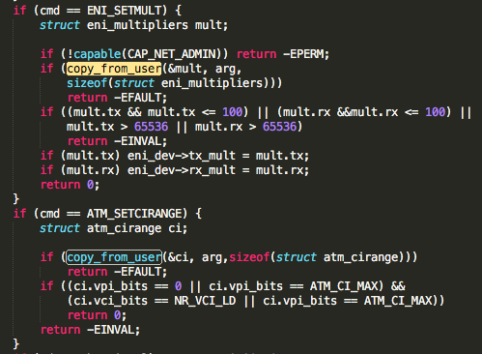

/Users/wpf/Desktop/log/test/linux-2.6.9/drivers/isdn/capi/kcapi.c

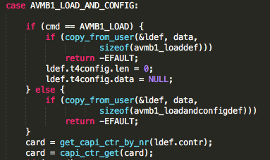

/Users/wpf/Desktop/log/test/linux-2.6.9/drivers/isdn/hardware/eicon/divasi.c

/Users/wpf/Desktop/log/test/linux-2.6.9/drivers/scsi/megaraid/megaraid_mm.c

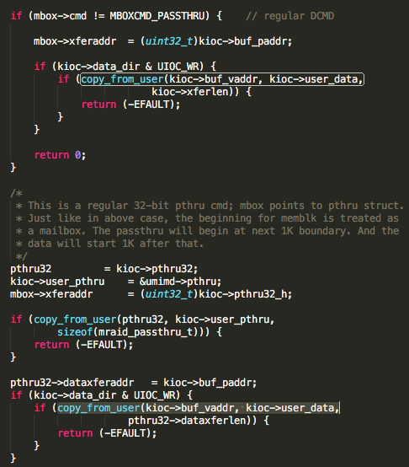

/Users/wpf/Desktop/log/test/linux-2.6.9/drivers/usb/input/hiddev.c

# 3. different offset (++)

/Users/wpf/Desktop/log/test/linux-2.6.9/drivers/char/vt_ioctl.c

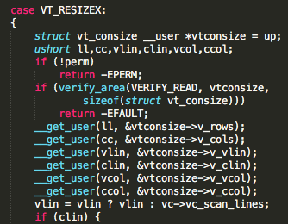

/Users/wpf/Desktop/log/test/linux-2.6.9/drivers/char/dsp56k.c

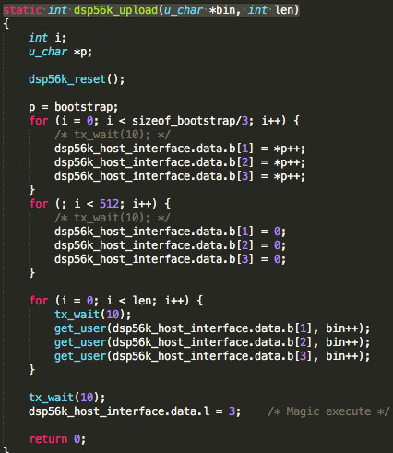

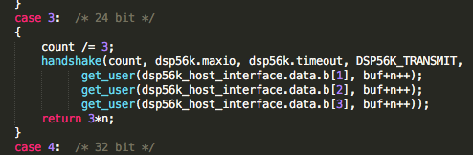

/Users/wpf/Desktop/log/test/linux-2.6.9/drivers/char/dtlk.c

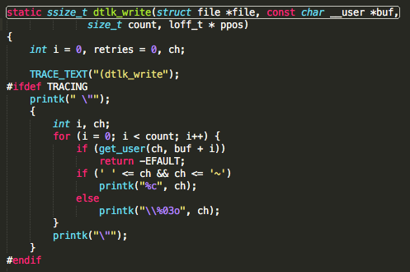

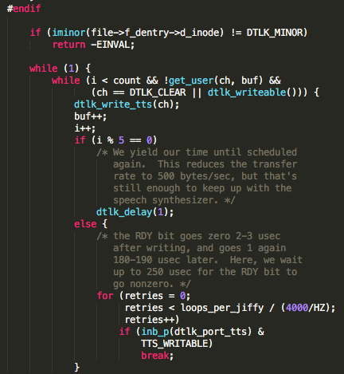

/Users/wpf/Desktop/log/test/linux-2.6.9/drivers/char/i8k.c

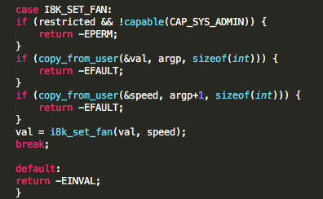

/Users/wpf/Desktop/log/test/linux-2.6.9/drivers/char/lp.c

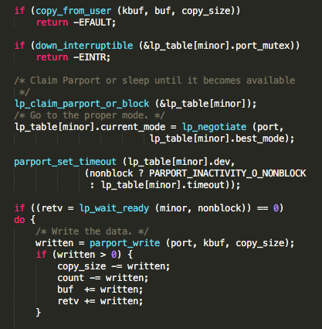

/Users/wpf/Desktop/log/test/linux-2.6.9/drivers/char/ppdev.c

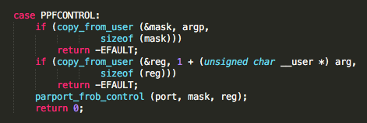

/Users/wpf/Desktop/log/test/linux-2.6.9/drivers/isdn/hardware/avm/b1.c

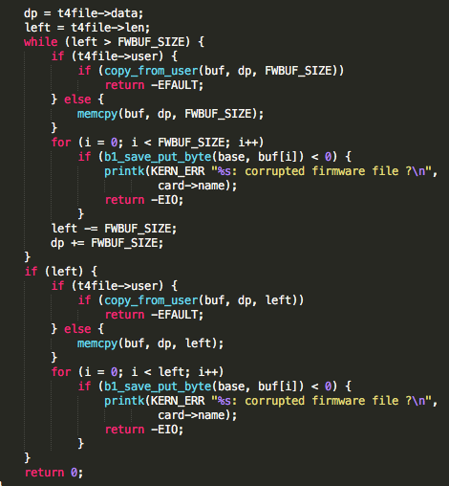X2

/Users/wpf/Desktop/log/test/linux-2.6.9/drivers/isdn/hardware/avm/c4.c

/Users/wpf/Desktop/log/test/linux-2.6.9/drivers/isdn/hisax/isar.c

/Users/wpf/Desktop/log/test/linux-2.6.9/drivers/isdn/i4l/isdn_common.c

/Users/wpf/Desktop/log/test/linux-2.6.9/drivers/net/wan/farsync.c

/Users/wpf/Desktop/log/test/linux-2.6.9/drivers/telephony/ixj.c

/Users/wpf/Desktop/log/test/linux-2.6.9/drivers/usb/gadget/inode.c

/Users/wpf/Desktop/log/test/linux-2.6.9/drivers/video/sbuslib.c

/Users/wpf/Desktop/log/test/linux-2.6.9/drivers/char/mwave/3780i.c

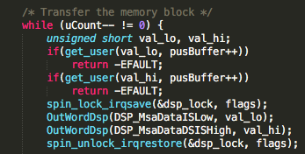

/Users/wpf/Desktop/log/test/linux-2.6.9/drivers/char/sx.c

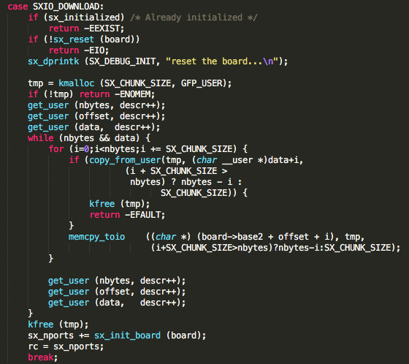

/Users/wpf/Desktop/log/test/linux-2.6.9/drivers/char/vt.c

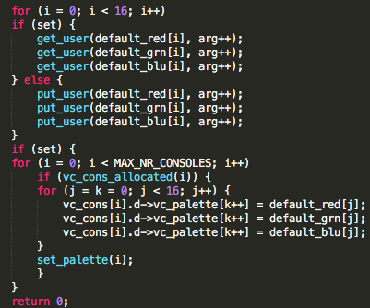

/Users/wpf/Desktop/log/test/linux-2.6.9/drivers/input/evdev.c

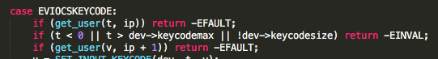

/Users/wpf/Desktop/log/test/linux-2.6.9/drivers/macintosh/ans-lcd.c

/Users/wpf/Desktop/log/test/linux-2.6.9/drivers/media/video/planb.c

/Users/wpf/Desktop/log/test/linux-2.6.9/drivers/pci/proc.c

# 4. deep_copy

/Users/wpf/Desktop/log/test/linux-2.6.9/drivers/block/DAC960.c

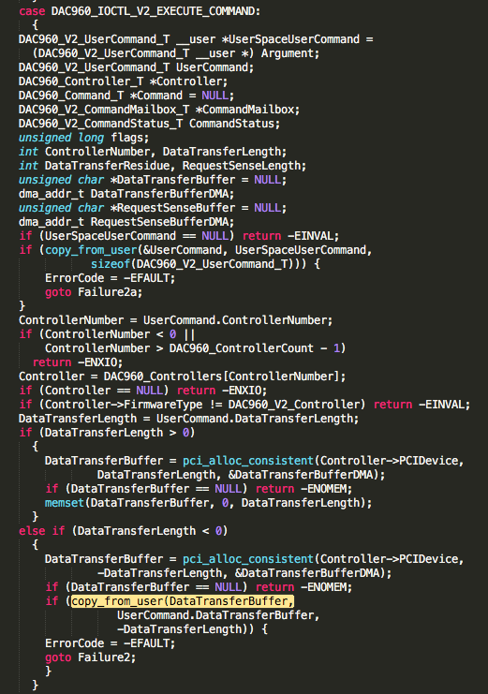

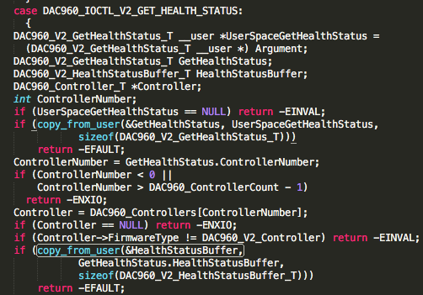

/Users/wpf/Desktop/log/test/linux-2.6.9/drivers/block/cciss.c

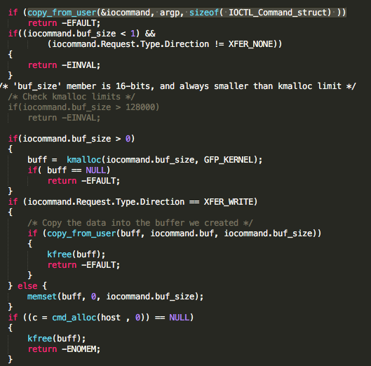

/Users/wpf/Desktop/log/test/linux-2.6.9/drivers/char/drm/drm_bufs.h

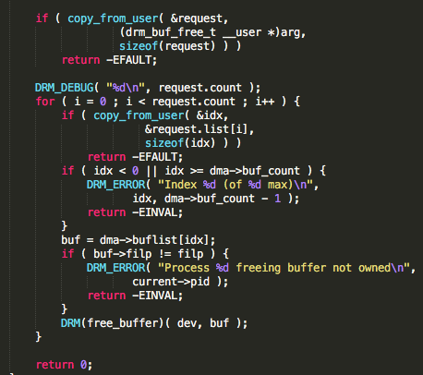

/Users/wpf/Desktop/log/test/linux-2.6.9/drivers/char/lcd.c

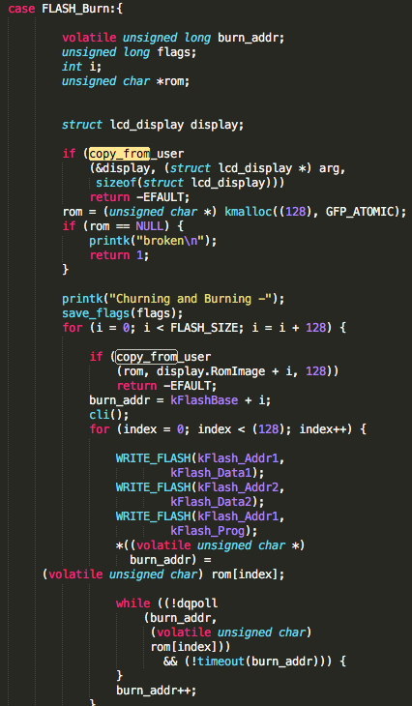

/Users/wpf/Desktop/log/test/linux-2.6.9/drivers/i2c/i2c-dev.c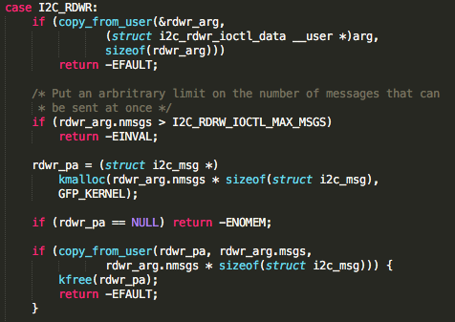 X 2

/Users/wpf/Desktop/log/test/linux-2.6.9/drivers/media/video/stradis.c

/Users/wpf/Desktop/log/test/linux-2.6.9/drivers/mtd/mtdchar.c

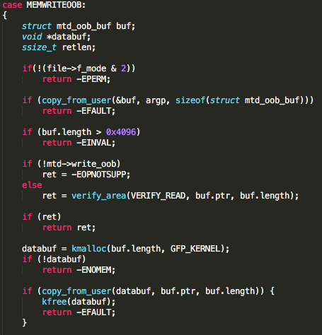

/Users/wpf/Desktop/log/test/linux-2.6.9/drivers/net/sk98lin/skge.c

/Users/wpf/Desktop/log/test/linux-2.6.9/drivers/telephony/ixj.c

/Users/wpf/Desktop/log/test/linux-2.6.9/drivers/usb/core/devio.c

/Users/wpf/Desktop/log/test/linux-2.6.9/drivers/usb/misc/rio500.c

# 5 false report

static int

static struct watchdog_info ident=

xdi_copy_from_user);

/Users/wpf/Desktop/log/test/linux-2.6.9/drivers/isdn/hardware/eicon/divasmain.c

no copy funcs

/Users/wpf/Desktop/log/test/linux-2.6.9/drivers/net/wireless/atmel.c

##deleted

/Users/wpf/Desktop/log/test/linux-2.6.9/drivers/char/rio/rio_linux.c

/Users/wpf/Desktop/log/test/linux-2.6.9/drivers/char/viocons.c

# 6 pattern

/Users/wpf/Desktop/log/test/linux-2.6.9/drivers/net/dl2k.c

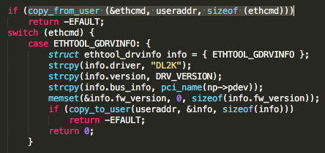

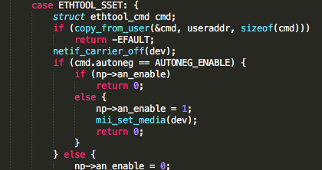

/Users/wpf/Desktop/log/test/linux-2.6.9/drivers/net/eepro100.c 同上

/Users/wpf/Desktop/log/test/linux-2.6.9/drivers/net/ewrk3.c同上

/Users/wpf/Desktop/log/test/linux-2.6.9/drivers/net/forcedeth.c 同上

/Users/wpf/Desktop/log/test/linux-2.6.9/drivers/net/hamachi.c同上

/Users/wpf/Desktop/log/test/linux-2.6.9/drivers/net/hamradio/yam.c 同上

/Users/wpf/Desktop/log/test/linux-2.6.9/drivers/net/ixgb/ixgb_ethtool.c同上

/Users/wpf/Desktop/log/test/linux-2.6.9/drivers/net/natsemi.c 同上

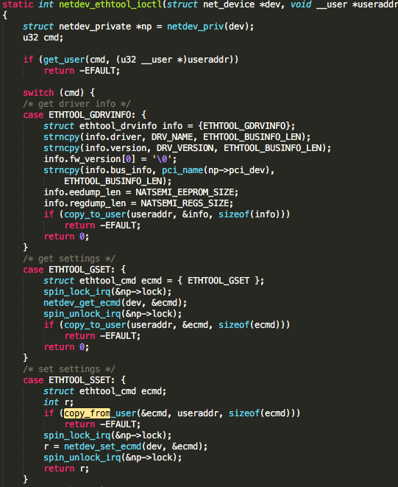

/Users/wpf/Desktop/log/test/linux-2.6.9/drivers/net/pcmcia/smc91c92_cs.c同上

/Users/wpf/Desktop/log/test/linux-2.6.9/drivers/net/sundance.c同上

/Users/wpf/Desktop/log/test/linux-2.6.9/drivers/net/typhoon.c同上

/Users/wpf/Desktop/log/test/linux-2.6.9/drivers/net/wan/lmc/lmc_main.c同上

/Users/wpf/Desktop/log/test/linux-2.6.9/drivers/usb/net/pegasus.c同上

# 7 potential

/Users/wpf/Desktop/log/test/linux-2.6.9/drivers/char/tpqic02.c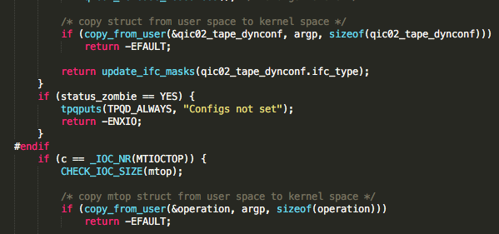

/Users/wpf/Desktop/log/test/linux-2.6.9/drivers/isdn/hysdn/hysdn_procconf.c

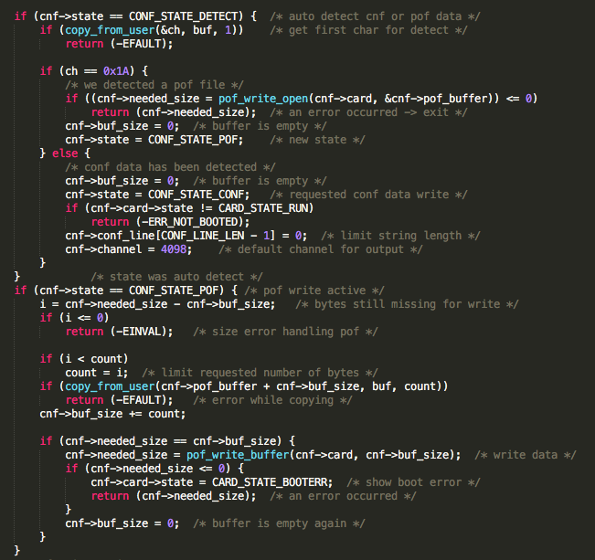

/Users/wpf/Desktop/log/test/linux-2.6.9/drivers/md/dm-ioctl.c

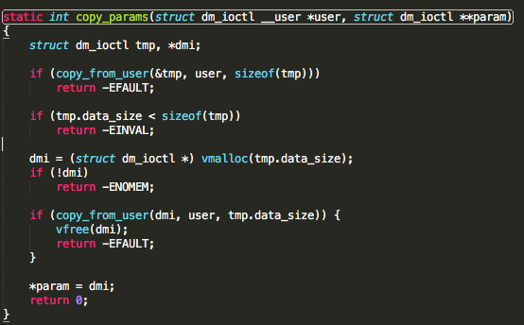

/Users/wpf/Desktop/log/test/linux-2.6.9/drivers/md/md.c

/Users/wpf/Desktop/log/test/linux-2.6.9/drivers/media/video/zr36120.c

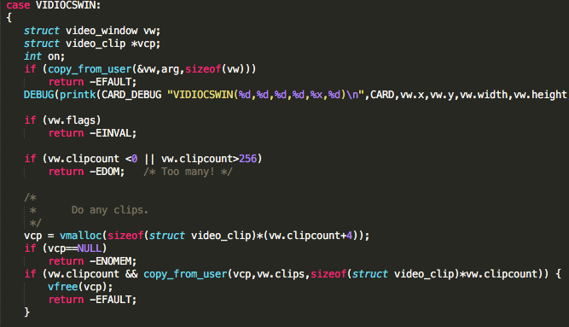

/Users/wpf/Desktop/log/test/linux-2.6.9/drivers/scsi/3w-9xxx.c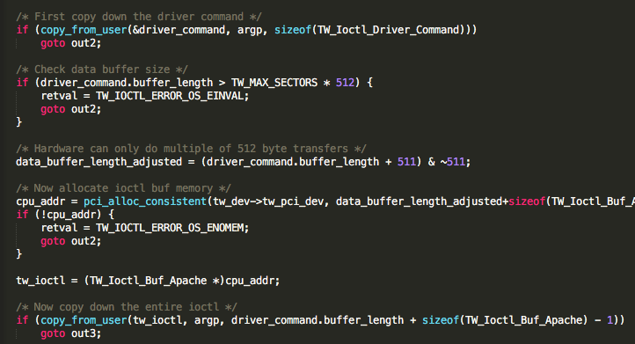

/Users/wpf/Desktop/log/test/linux-2.6.9/drivers/scsi/3w-xxxx.c

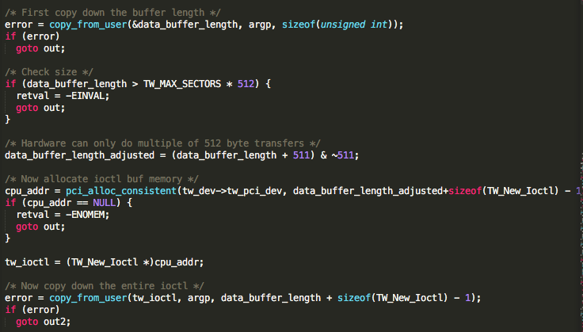

/Users/wpf/Desktop/log/test/linux-2.6.9/drivers/scsi/aacraid/commctrl.c

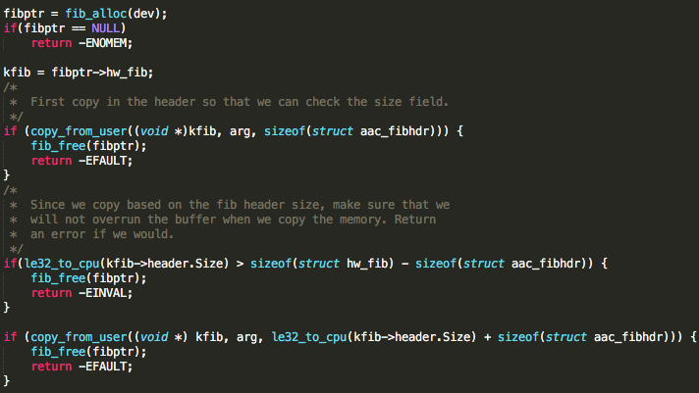

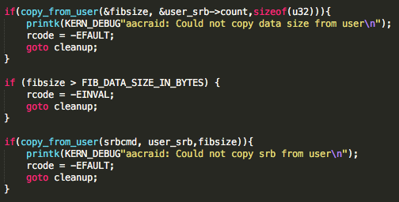

/Users/wpf/Desktop/log/test/linux-2.6.9/drivers/scsi/dpt_i2o.c

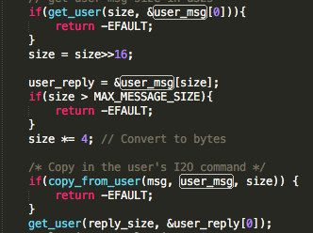

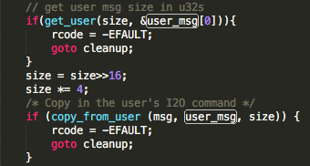

# Linux kernel 4.3.3

## Different offset （33）

/Users/wpf/Documents/workspace/text-filter/test/linux-4.3.3/arch/alpha/lib/csum_partial_copy.c

/Users/wpf/Documents/workspace/text-filter/test/linux-4.3.3/arch/cris/arch-v10/drivers/sync_serial.c

/Users/wpf/Documents/workspace/text-filter/test/linux-4.3.3/arch/cris/arch-v10/lib/usercopy.c

/Users/wpf/Documents/workspace/text-filter/test/linux-4.3.3/arch/cris/arch-v32/lib/usercopy.c

/Users/wpf/Documents/workspace/text-filter/test/linux-4.3.3/arch/ia64/kernel/ptrace.c

/Users/wpf/Documents/workspace/text-filter/test/linux-4.3.3/arch/metag/lib/usercopy.c

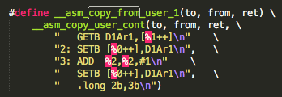Macintosh HD:Users:wpf:Desktop:屏幕快照 2016-04-05 下午5.53.03.png

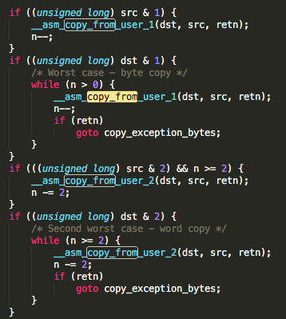

/Users/wpf/Documents/workspace/text-filter/test/linux-4.3.3/arch/mips/kernel/branch.c

/Users/wpf/Documents/workspace/text-filter/test/linux-4.3.3/arch/mips/kernel/traps.c

/Users/wpf/Documents/workspace/text-filter/test/linux-4.3.3/arch/mips/kernel/unaligned.c

/Users/wpf/Documents/workspace/text-filter/test/linux-4.3.3/arch/mn10300/mm/misalignment.c

/Users/wpf/Documents/workspace/text-filter/test/linux-4.3.3/arch/powerpc/platforms/cell/spufs/file.c

/Users/wpf/Documents/workspace/text-filter/test/linux-4.3.3/arch/s390/include/asm/idals.h

/Users/wpf/Documents/workspace/text-filter/test/linux-4.3.3/drivers/char/lp.c

/Users/wpf/Documents/workspace/text-filter/test/linux-4.3.3/drivers/infiniband/core/user_mad.c

/Users/wpf/Documents/workspace/text-filter/test/linux-4.3.3/drivers/isdn/hardware/avm/b1.c

/Users/wpf/Documents/workspace/text-filter/test/linux-4.3.3/drivers/isdn/hardware/avm/c4.c

/Users/wpf/Documents/workspace/text-filter/test/linux-4.3.3/drivers/isdn/hisax/isar.c

/Users/wpf/Documents/workspace/text-filter/test/linux-4.3.3/drivers/isdn/i4l/isdn_common.c

/Users/wpf/Documents/workspace/text-filter/test/linux-4.3.3/drivers/lguest/lguest_user.c

/Users/wpf/Documents/workspace/text-filter/test/linux-4.3.3/drivers/macintosh/ans-lcd.c

/Users/wpf/Documents/workspace/text-filter/test/linux-4.3.3/drivers/mtd/ubi/upd.c

/Users/wpf/Documents/workspace/text-filter/test/linux-4.3.3/drivers/pci/proc.c

/Users/wpf/Documents/workspace/text-filter/test/linux-4.3.3/drivers/s390/char/monwriter.c

/Users/wpf/Documents/workspace/text-filter/test/linux-4.3.3/drivers/staging/rdma/hfi1/user_sdma.c

/Users/wpf/Documents/workspace/text-filter/test/linux-4.3.3/drivers/staging/rdma/ipath/ipath_diag.c

/Users/wpf/Documents/workspace/text-filter/test/linux-4.3.3/fs/binfmt_flat.c

/Users/wpf/Documents/workspace/text-filter/test/linux-4.3.3/lib/iov_iter.c

/Users/wpf/Documents/workspace/text-filter/test/linux-4.3.3/net/decnet/af_decnet.c

/Users/wpf/Documents/workspace/text-filter/test/linux-4.3.3/sound/core/compress_offload.c

/Users/wpf/Documents/workspace/text-filter/test/linux-4.3.3/sound/isa/sb/emu8000_pcm.c

/Users/wpf/Documents/workspace/text-filter/test/linux-4.3.3/sound/isa/sb/sb16_csp.c

/Users/wpf/Documents/workspace/text-filter/test/linux-4.3.3/sound/pci/emu10k1/emu10k1_patch.c

/Users/wpf/Documents/workspace/text-filter/test/linux-4.3.3/sound/synth/emux/soundfont.c

## Different Branch (41)

/Users/wpf/Documents/workspace/text-filter/test/linux-4.3.3/arch/arm/nwfpe/fpa11_cpdt.c

/Users/wpf/Documents/workspace/text-filter/test/linux-4.3.3/arch/cris/include/asm/uaccess.h

/Users/wpf/Documents/workspace/text-filter/test/linux-4.3.3/arch/hexagon/include/asm/uaccess.h

/Users/wpf/Documents/workspace/text-filter/test/linux-4.3.3/arch/m32r/kernel/traps.c

/Users/wpf/Documents/workspace/text-filter/test/linux-4.3.3/arch/mips/include/asm/compat-signal.h

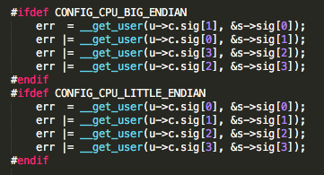

/Users/wpf/Documents/workspace/text-filter/test/linux-4.3.3/arch/parisc/kernel/signal.c

/Users/wpf/Documents/workspace/text-filter/test/linux-4.3.3/arch/parisc/kernel/signal32.c

/Users/wpf/Documents/workspace/text-filter/test/linux-4.3.3/arch/s390/kernel/compat_signal.c

/Users/wpf/Documents/workspace/text-filter/test/linux-4.3.3/arch/sparc/kernel/perf_event.c

/Users/wpf/Documents/workspace/text-filter/test/linux-4.3.3/block/ioctl.c –differ case

/Users/wpf/Documents/workspace/text-filter/test/linux-4.3.3/block/scsi_ioctl.c –differ case

/Users/wpf/Documents/workspace/text-filter/test/linux-4.3.3/drivers/atm/eni.c

/Users/wpf/Documents/workspace/text-filter/test/linux-4.3.3/drivers/gpu/drm/amd/amdgpu/amdgpu_bo_list.c

/Users/wpf/Documents/workspace/text-filter/test/linux-4.3.3/drivers/hid/uhid.c

/Users/wpf/Documents/workspace/text-filter/test/linux-4.3.3/drivers/hid/usbhid/hiddev.c

/Users/wpf/Documents/workspace/text-filter/test/linux-4.3.3/drivers/input/input-compat.c

/Users/wpf/Documents/workspace/text-filter/test/linux-4.3.3/drivers/input/misc/uinput.c

/Users/wpf/Documents/workspace/text-filter/test/linux-4.3.3/drivers/isdn/capi/kcapi.c

/Users/wpf/Documents/workspace/text-filter/test/linux-4.3.3/drivers/media/dvb-core/dvb_frontend.c

/Users/wpf/Documents/workspace/text-filter/test/linux-4.3.3/drivers/media/pci/ivtv/ivtv-fileops.c

/Users/wpf/Documents/workspace/text-filter/test/linux-4.3.3/drivers/media/pci/ivtv/ivtvfb.c

/Users/wpf/Documents/workspace/text-filter/test/linux-4.3.3/drivers/media/v4l2-core/v4l2-compat-ioctl32.c

/Users/wpf/Documents/workspace/text-filter/test/linux-4.3.3/drivers/misc/vmw_vmci/vmci_host.c

/Users/wpf/Documents/workspace/text-filter/test/linux-4.3.3/drivers/net/tun.c

/Users/wpf/Documents/workspace/text-filter/test/linux-4.3.3/drivers/staging/rdma/hfi1/diag.c

/Users/wpf/Documents/workspace/text-filter/test/linux-4.3.3/drivers/tty/mxser.c

/Users/wpf/Documents/workspace/text-filter/test/linux-4.3.3/drivers/vfio/pci/vfio_pci.c

/Users/wpf/Documents/workspace/text-filter/test/linux-4.3.3/drivers/vfio/pci/vfio_pci_rdwr.c

/Users/wpf/Documents/workspace/text-filter/test/linux-4.3.3/drivers/vfio/platform/vfio_platform_common.c

/Users/wpf/Documents/workspace/text-filter/test/linux-4.3.3/drivers/vfio/vfio_iommu_type1.c

/Users/wpf/Documents/workspace/text-filter/test/linux-4.3.3/kernel/seccomp.c

/Users/wpf/Documents/workspace/text-filter/test/linux-4.3.3/net/core/pktgen.c

/Users/wpf/Documents/workspace/text-filter/test/linux-4.3.3/net/ipv4/ip_sockglue.c

/Users/wpf/Documents/workspace/text-filter/test/linux-4.3.3/net/sctp/socket.c

/Users/wpf/Documents/workspace/text-filter/test/linux-4.3.3/sound/core/memory.c

/Users/wpf/Documents/workspace/text-filter/test/linux-4.3.3/sound/core/seq/oss/seq_oss_timer.c

/Users/wpf/Documents/workspace/text-filter/test/linux-4.3.3/sound/isa/sb/emu8000_patch.c

/Users/wpf/Documents/workspace/text-filter/test/linux-4.3.3/sound/oss/ad1848.c

/Users/wpf/Documents/workspace/text-filter/test/linux-4.3.3/sound/oss/pas2_mixer.c

/Users/wpf/Documents/workspace/text-filter/test/linux-4.3.3/sound/oss/sb_mixer.c

/Users/wpf/Documents/workspace/text-filter/test/linux-4.3.3/sound/oss/swarm_cs4297a.c

## size control (7-4)

/Users/wpf/Documents/workspace/text-filter/test/linux-4.3.3/arch/powerpc/platforms/powernv/opal-prd.c

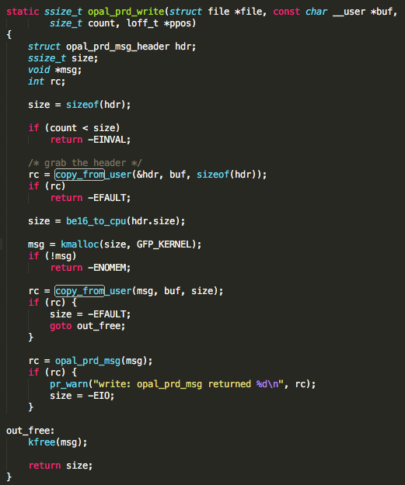

arch/powerpc/include/asm/opal.h

int64_t opal_prd_msg(struct opal_prd_msg *msg);

<https://github.com/open-power/skiboot/blob/master/hw/prd.c>

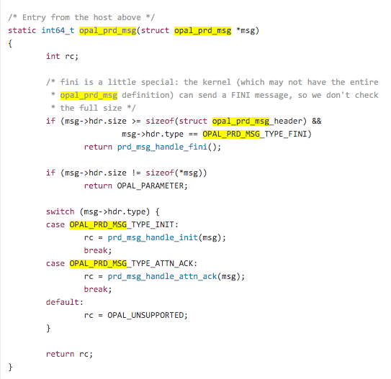

/Users/wpf/Documents/workspace/text-filter/test/linux-4.3.3/net/core/ethtool.c

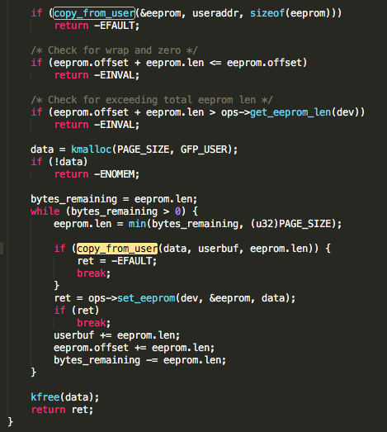

/Users/wpf/Documents/workspace/text-filter/test/linux-4.3.3/drivers/scsi/dpt_i2o.c

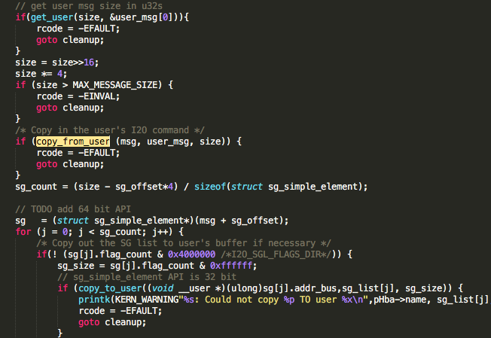

/Users/wpf/Documents/workspace/text-filter/test/linux-4.3.3/drivers/scsi/3w-xxxx.c

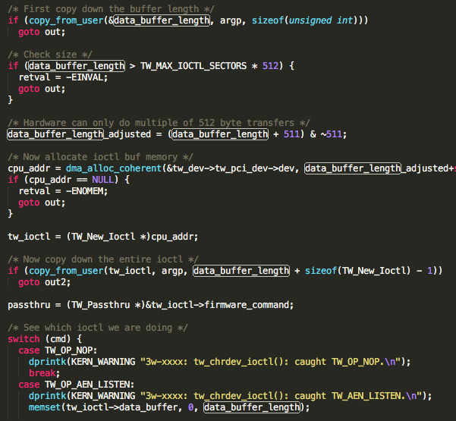

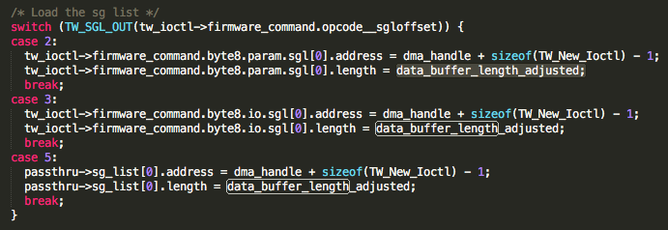

/Users/wpf/Documents/workspace/text-filter/test/linux-4.3.3/fs/coda/psdev.c

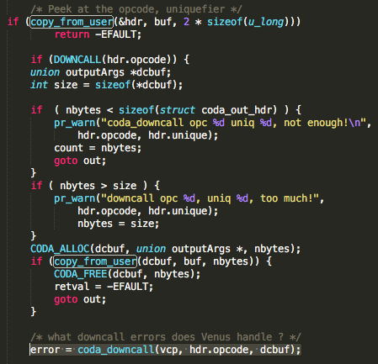

/Users/wpf/Documents/workspace/text-filter/test/linux-4.3.3/drivers/scsi/3w-9xxx.c

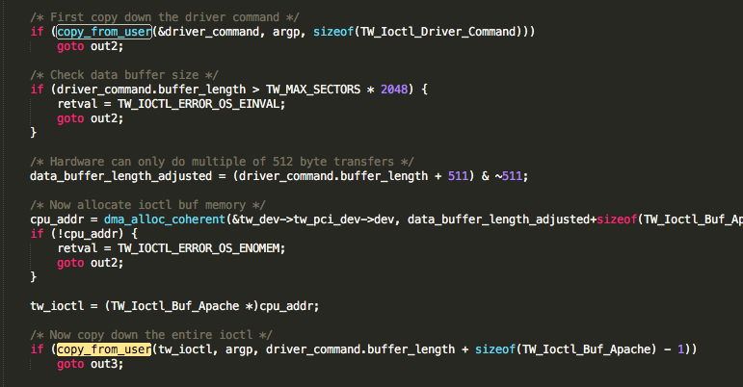

/Users/wpf/Documents/workspace/text-filter/test/linux-4.3.3/drivers/scsi/3w-sas.c -同上

## cmd (8-8)

/Users/wpf/Documents/workspace/text-filter/test/linux-4.3.3/drivers/net/ethernet/chelsio/cxgb3/cxgb3_main.c

/Users/wpf/Documents/workspace/text-filter/test/linux-4.3.3/drivers/net/hamradio/scc.c

/Users/wpf/Documents/workspace/text-filter/test/linux-4.3.3/drivers/platform/chrome/cros_ec_dev.c

/Users/wpf/Documents/workspace/text-filter/test/linux-4.3.3/drivers/android/binder.c

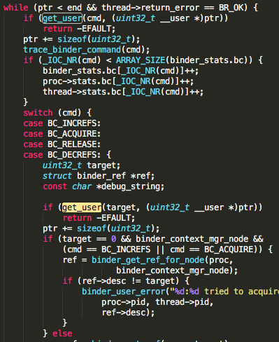

/Users/wpf/Documents/workspace/text-filter/test/linux-4.3.3/drivers/isdn/hysdn/hysdn_procconf.c

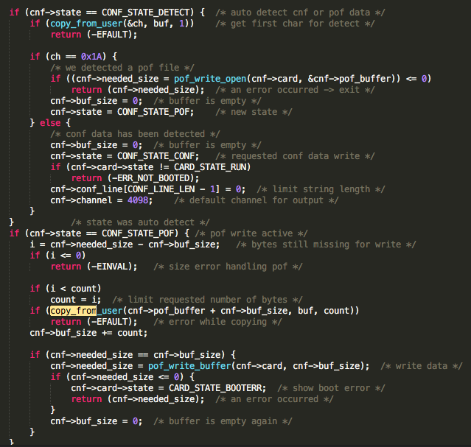

/Users/wpf/Documents/workspace/text-filter/test/linux-4.3.3/drivers/net/hamradio/yam.c

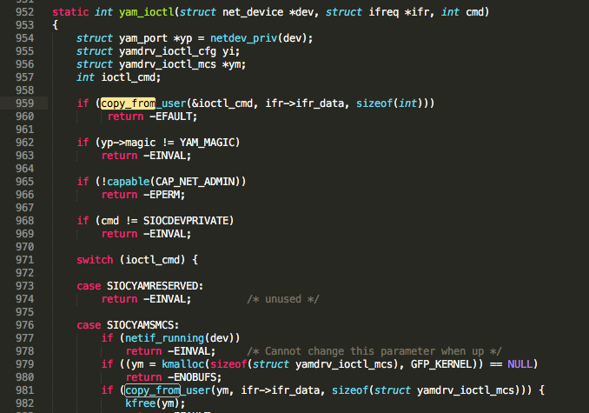

/Users/wpf/Documents/workspace/text-filter/test/linux-4.3.3/drivers/scsi/megaraid.c --signature

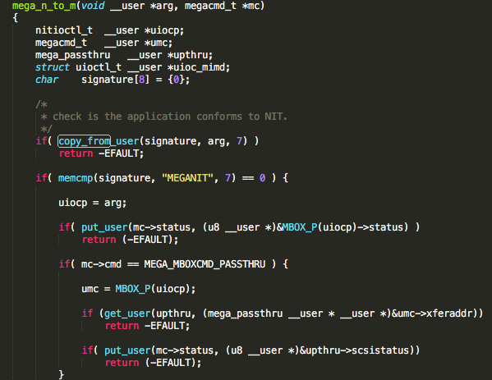

/Users/wpf/Documents/workspace/text-filter/test/linux-4.3.3/drivers/staging/lustre/lustre/include/obd.h

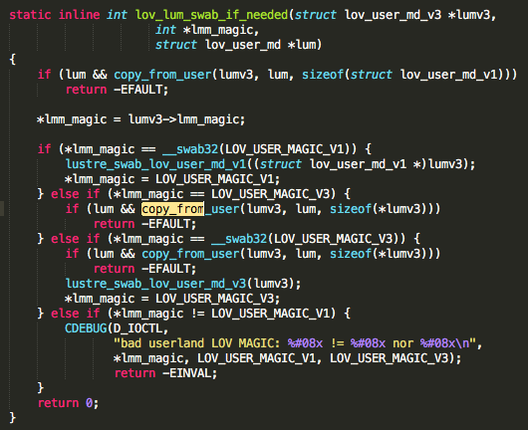

## deep(2-1)

/Users/wpf/Documents/workspace/text-filter/test/linux-4.3.3/drivers/mtd/mtdchar.c

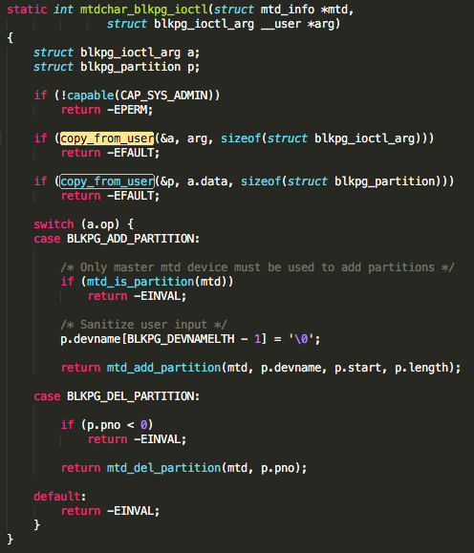

/Users/wpf/Documents/workspace/text-filter/test/linux-4.3.3/fs/ncpfs/ioctl.c

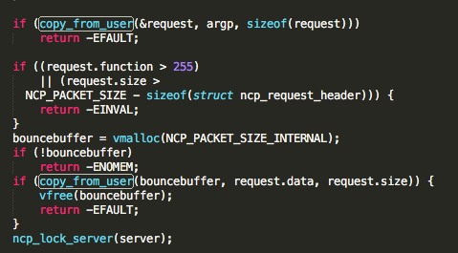

## double(4-2)

/Users/wpf/Documents/workspace/text-filter/test/linux-4.3.3/drivers/scsi/sg.c

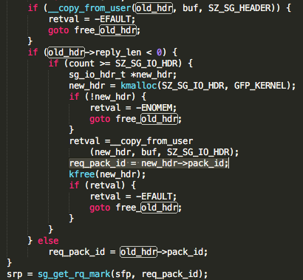

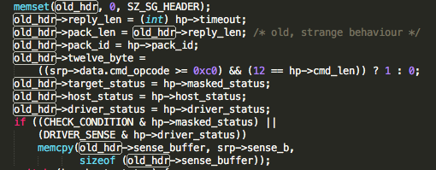

/Users/wpf/Documents/workspace/text-filter/test/linux-4.3.3/net/compat.c

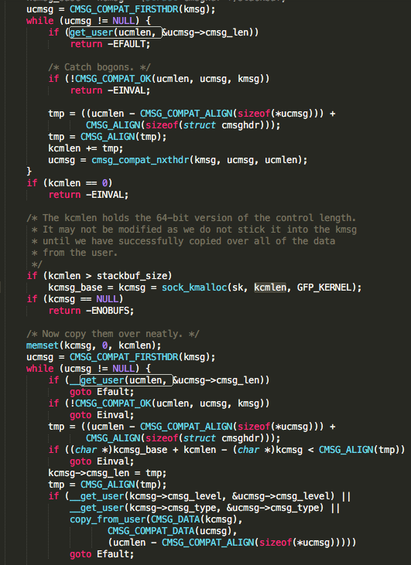

/Users/wpf/Documents/workspace/text-filter/test/linux-4.3.3/arch/frv/kernel/traps.c

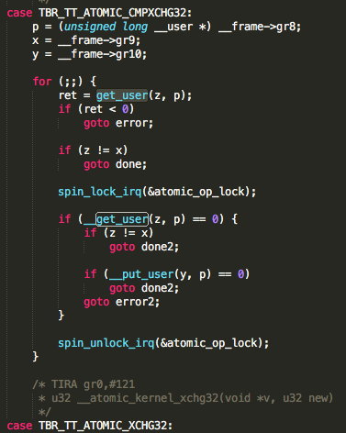

/Users/wpf/Documents/workspace/text-filter/test/linux-4.3.3/drivers/gpu/drm/i915/i915_gem.c

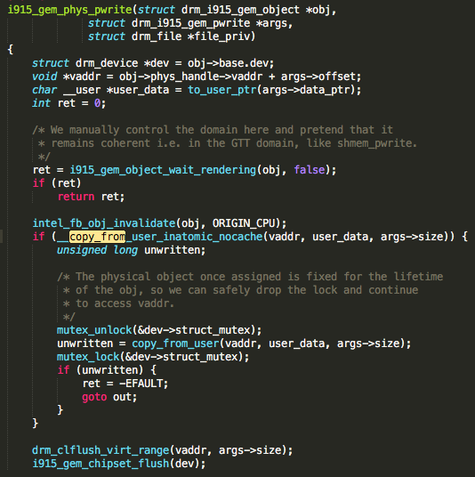

## ？？(2-1)

/Users/wpf/Documents/workspace/text-filter/test/linux-4.3.3/arch/sparc/include/asm/uaccess_64.h

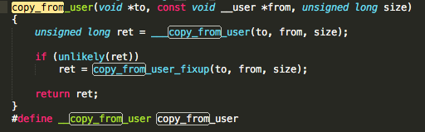

/Users/wpf/Documents/workspace/text-filter/test/linux-4.3.3/drivers/staging/rtl8712/rtl871x_ioctl_linux.c

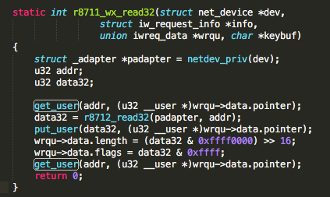

/Users/wpf/Documents/workspace/text-filter/test/linux-4.3.3/net/ipv4/tcp.c

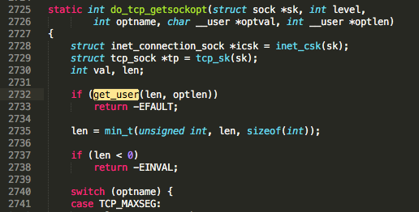

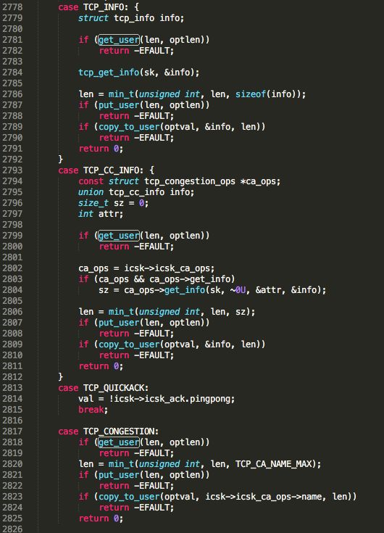

## protection (3-3)

/Users/wpf/Documents/workspace/text-filter/test/linux-4.3.3/drivers/md/dm-ioctl.c //size control

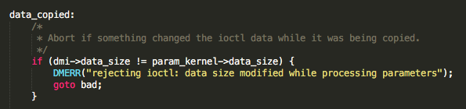

/Users/wpf/Documents/workspace/text-filter/test/linux-4.3.3/drivers/staging/lustre/lustre/libcfs/linux/linux-module.c //size control

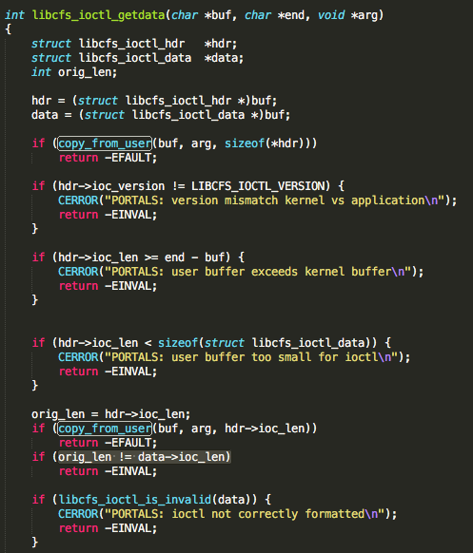 //size control

/Users/wpf/Documents/workspace/text-filter/test/linux-4.3.3/drivers/staging/lustre/lustre/obdclass/linux/linux-module.c //size control

# ~~~~(3-3)

/Users/wpf/Documents/workspace/text-filter/test/linux-4.3.3/drivers/s390/char/sclp_ctl.c

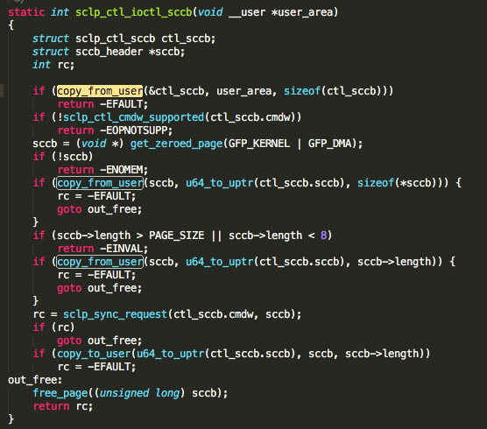

/Users/wpf/Documents/workspace/text-filter/test/linux-4.3.3/drivers/misc/mic/host/mic_virtio.c

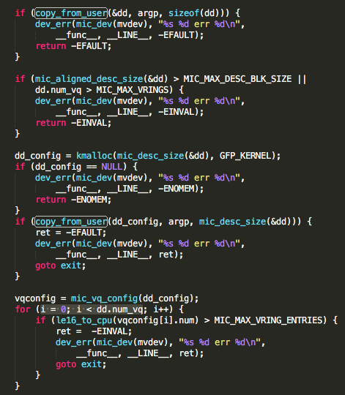

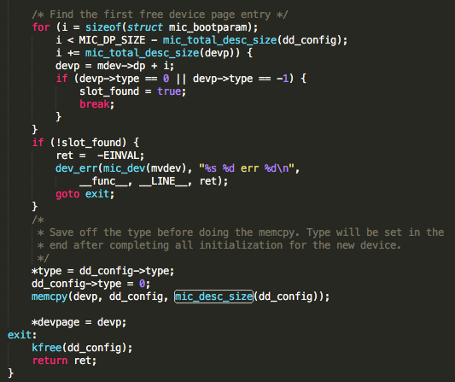

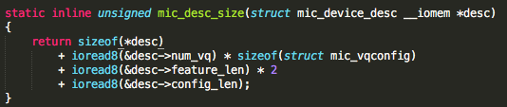

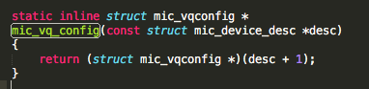

struct mic_device_desc {

__s8 type;

__u8 num_vq;

__u8 feature_len;

__u8 config_len;

__u8 status;

__le64 config[0];

} __attribute__ ((aligned(8)));

struct mic_vqconfig {

__le64 address;

__le64 used_address;

__le16 num;

} __attribute__ ((aligned(8)));

/Users/wpf/Documents/workspace/text-filter/test/linux-4.3.3/drivers/scsi/aacraid/commctrl.c

